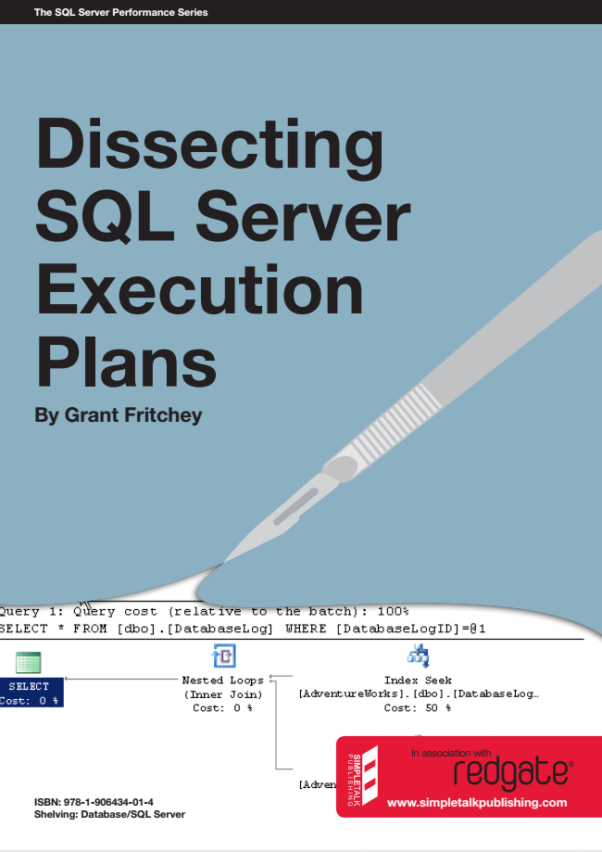

The SQL Server Performance Series

Dissecting SQL Server Execution Plans

By Grant Fritchey

ISBN: 978-1-906434-01-4 Shelving: Database/SQL Server

In association with

www.simpletalkpublishing.com

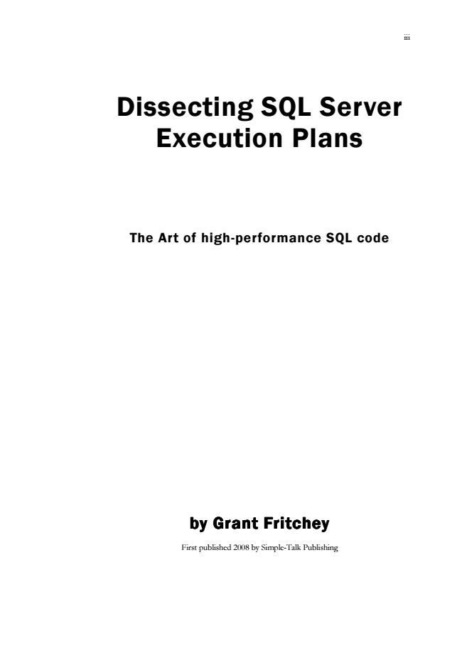

iii

Dissecting SQL Server Execution Plans

The Art of high-performance SQL code

by by by by Grant Fritchey Grant Fritchey Grant Fritchey Grant Fritchey

First published 2008 by Simple-Talk Publishing



iv

Copyright Grant Fritchey 2008

ISBN 978-1-906434-01-4

The right of Grant Fritcheyto be identified as the author of this work has been asserted by him in accordance with the Copyright, Designs and Patents Act 1988

All rights reserved. No part of this publication may be reproduced, stored or introduced into a retrieval system, or transmitted, in any form, or by any means (electronic, mechanical, photocopying, recording or otherwise) without the prior written consent of the publisher. Any person who does any unauthorised act in relation to this publication may be liable to criminal prosecution and civil claims for damages.

This book is sold subject to the condition that it shall not, by way of trade or otherwise, be lent, re-sold, hired out, or otherwise circulated without the publisher’s prior consent in any form other than which it is published and without a similar condition including this condition being imposed on the subsequent publisher.

Typeset by Andrew Clarke

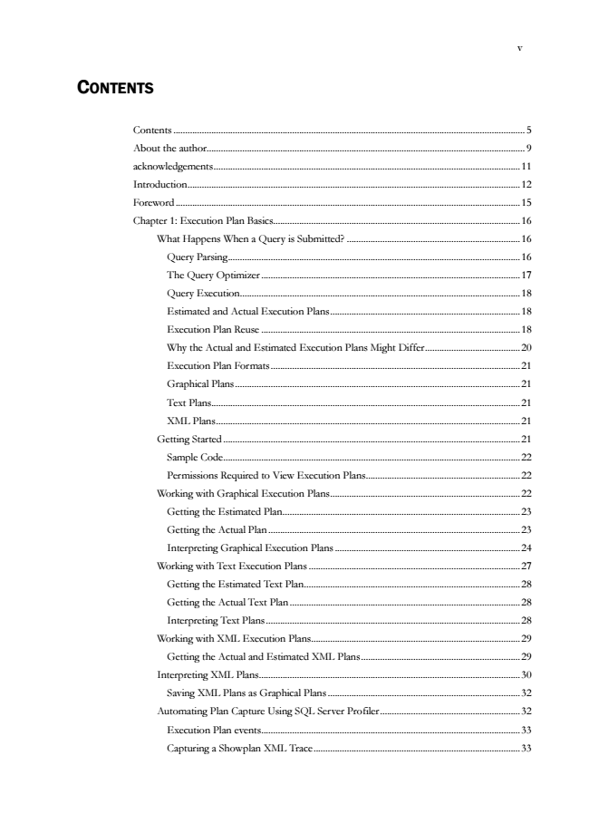

v

C

ONTENTS

Contents .................................................................................................................................................... 5

About the author...................................................................................................................................... 9

acknowledgements.................................................................................................................................11

Introduction............................................................................................................................................12

Foreword.................................................................................................................................................15

Chapter 1: Execution Plan Basics........................................................................................................16

W hat Happens W hen a Query is Submitted? .........................................................................16

Query Parsing...........................................................................................................................16

The Query Optimizer ............................................................................................................. 17

Query Execution......................................................................................................................18

Estimated and Actual Execution Plans................................................................................18

Execution Plan Reuse .............................................................................................................18

W hy the Actual and Estimated Execution Plans Might Differ........................................20

Execution Plan Formats.........................................................................................................21

Graphical Plans ........................................................................................................................ 21

Text Plans..................................................................................................................................21

XML Plans................................................................................................................................21

Getting Started.............................................................................................................................21

Sample Code.............................................................................................................................22

Permissions Required to View Execution Plans.................................................................22

Working with Graphical Execution Plans................................................................................22

Getting the Estimated Plan....................................................................................................23

Getting the Actual Plan ..........................................................................................................23

Interpreting Graphical Execution Plans ..............................................................................24

Working with Text Execution Plans .........................................................................................27

Getting the Estimated Text Plan...........................................................................................28

Getting the Actual Text Plan .................................................................................................28

Interpreting Text Plans ........................................................................................................... 28

Working with XML Execution Plans........................................................................................29

Getting the Actual and Estimated XML Plans...................................................................29

Interpreting XML Plans..............................................................................................................30

Saving XML Plans as Graphical Plans .................................................................................32

Automating Plan Capture Using SQL Server Profiler...........................................................32

Execution Plan events.............................................................................................................33

Capturing a Showplan XML Trace.......................................................................................33

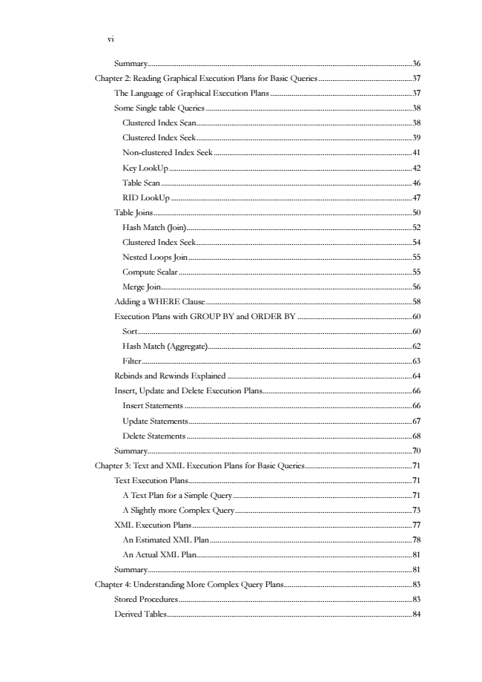

vi

Summary........................................................................................................................................36

Chapter 2: Reading Graphical Execution Plans for Basic Queries ................................................37

The Language of Graphical Execution Plans .........................................................................37

Some Single table Queries ..........................................................................................................38

Clustered Index Scan...............................................................................................................38

Clustered Index Seek...............................................................................................................39

Non-clustered Index Seek......................................................................................................41

Key LookUp.............................................................................................................................42

Table Scan .................................................................................................................................46

RID LookUp ............................................................................................................................47

Table Joins.....................................................................................................................................50

Hash Match (Join)....................................................................................................................52

Clustered Index Seek...............................................................................................................54

Nested Loops Join...................................................................................................................55

Compute Scalar ........................................................................................................................55

Merge Join.................................................................................................................................56

Adding a W HERE Clause ..........................................................................................................58

Execution Plans with GROUP BY and ORDER BY ...........................................................60

Sort.............................................................................................................................................60

Hash Match (Aggregate).........................................................................................................62

Filter...........................................................................................................................................63

Rebinds and Rewinds Explained...............................................................................................64

Insert, Update and Delete Execution Plans.............................................................................66

Insert Statements .....................................................................................................................66

Update Statements...................................................................................................................67

Delete Statements ....................................................................................................................68

Summary........................................................................................................................................70

Chapter 3: Text and XML Execution Plans for Basic Queries.......................................................71

Text Execution Plans...................................................................................................................71

A Text Plan for a Simple Query............................................................................................71

A Slightly more Complex Query...........................................................................................73

XML Execution Plans.................................................................................................................77

An Estimated XM L Plan ........................................................................................................78

An Actual XML Plan...............................................................................................................81

Summary........................................................................................................................................81

Chapter 4: Understanding More Complex Query Plans..................................................................83

Stored Procedures........................................................................................................................83

Derived Tables..............................................................................................................................84

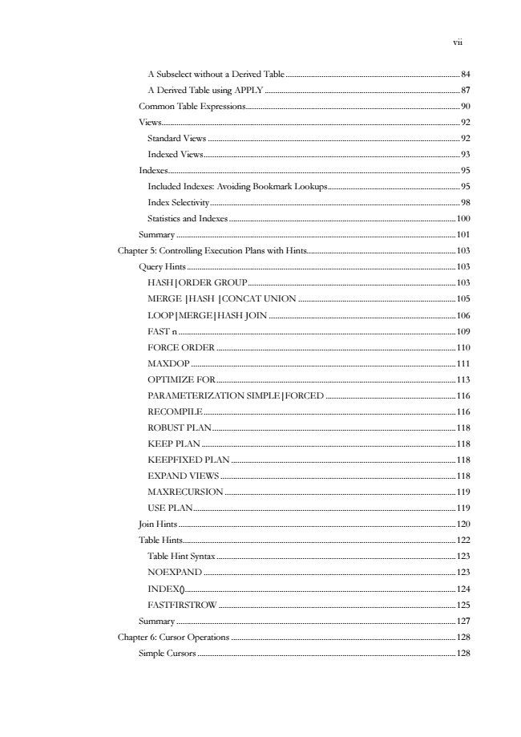

vii

A Subselect without a Derived Table ...................................................................................84

A Derived Table using APPLY .............................................................................................87

Common Table Expressions......................................................................................................90

Views..............................................................................................................................................92

Standard Views ........................................................................................................................ 92

Indexed Views..........................................................................................................................93

Indexes...........................................................................................................................................95

Included Indexes: Avoiding Bookmark Lookups...............................................................95

Index Selectivity.......................................................................................................................98

Statistics and Indexes ............................................................................................................100

Summary .....................................................................................................................................101

Chapter 5: Controlling Execution Plans with Hints.......................................................................103

Query Hints ................................................................................................................................103

HASH|ORDER GROUP...................................................................................................103

MERGE |HASH |CONCAT UNION ...........................................................................105

LOOP|MERGE|HASH JOIN .........................................................................................106

FAST n ....................................................................................................................................109

FORCE ORDER..................................................................................................................110

MAXDOP..............................................................................................................................111

OPTIMIZE FOR..................................................................................................................113

PARAMETERIZATION SIMPLE|FORCED ..............................................................116

RECOMPILE........................................................................................................................116

ROBUST PLAN....................................................................................................................118

KEEP PLAN .........................................................................................................................118

KEEPFIXED PLAN ...........................................................................................................118

EXPAND VIEW S................................................................................................................118

MAXRECURSION..............................................................................................................119

USE PLAN.............................................................................................................................119

Join Hints ....................................................................................................................................120

Table Hints..................................................................................................................................122

Table Hint Syntax..................................................................................................................123

NOEXPAND ........................................................................................................................123

INDEX().................................................................................................................................124

FASTFIRSTROW .................................................................................................................125

Summary .....................................................................................................................................127

Chapter 6: Cursor Operations ...........................................................................................................128

Simple Cursors ...........................................................................................................................128

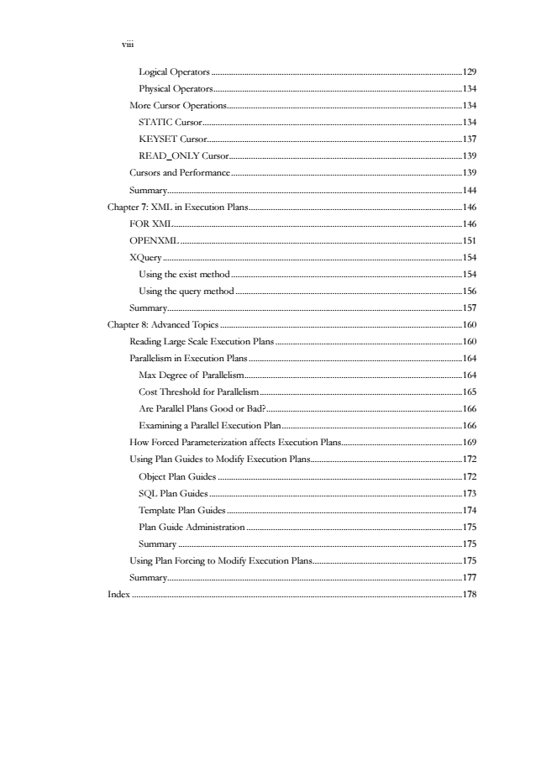

viii

Logical Operators ..................................................................................................................129

Physical Operators.................................................................................................................134

More Cursor Operations...........................................................................................................134

STATIC Cursor......................................................................................................................134

KEYSET Cursor....................................................................................................................137

READ_ONLY Cursor..........................................................................................................139

Cursors and Performance.........................................................................................................139

Summary......................................................................................................................................144

Chapter 7: XML in Execution Plans.................................................................................................146

FOR XML...................................................................................................................................146

OPENXML................................................................................................................................151

XQuery........................................................................................................................................154

Using the exist method.........................................................................................................154

Using the query method.......................................................................................................156

Summary......................................................................................................................................157

Chapter 8: Advanced Topics ..............................................................................................................160

Reading Large Scale Execution Plans .....................................................................................160

Parallelism in Execution Plans .................................................................................................164

Max Degree of Parallelism...................................................................................................164

Cost Threshold for Parallelism ............................................................................................165

Are Parallel Plans Good or Bad?.........................................................................................166

Examining a Parallel Execution Plan..................................................................................166

How Forced Parameterization affects Execution Plans.......................................................169

Using Plan Guides to Modify Execution Plans.....................................................................172

Object Plan Guides ...............................................................................................................172

SQL Plan Guides ...................................................................................................................173

Template Plan Guides ...........................................................................................................174

Plan Guide Administration ..................................................................................................175

Summary .................................................................................................................................175

Using Plan Forcing to Modify Execution Plans....................................................................175

Summary......................................................................................................................................177

Index......................................................................................................................................................178

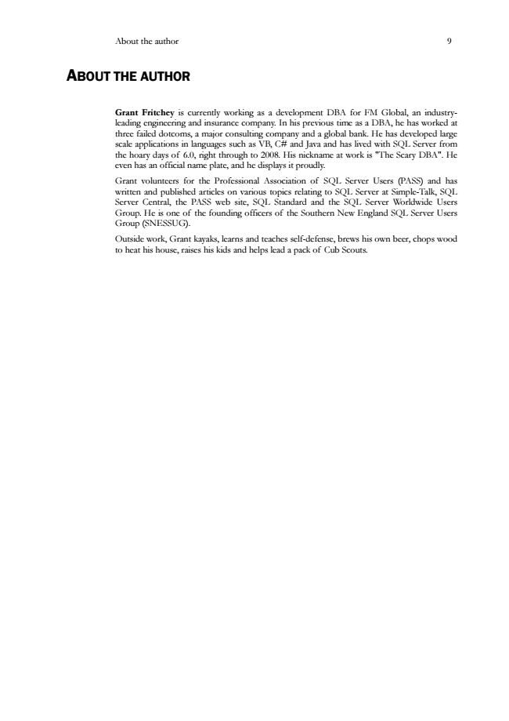

About the author 9

A

BOUT THE AUTHOR

Grant Fritchey is currently working as a development DBA for FM Global, an industry- leading engineering and insurance company. In his previous time as a DBA, he has worked at three failed dotcoms, a major consulting company and a global bank. He has developed large scale applications in languages such as VB, C# and Java and has lived with SQL Server from the hoary days of 6.0, right through to 2008. His nickname at work is "The Scary DBA". He even has an official name plate, and he displays it proudly.

Grant volunteers for the Professional Association of SQL Server Users (PASS) and has written and published articles on various topics relating to SQL Server at Simple-Talk, SQL Server Central, the PASS web site, SQL Standard and the SQL Server Worldwide Users Group. He is one of the founding officers of the Southern New England SQL Server Users Group (SNESSUG).

Outside work, Grant kayaks, learns and teaches self-defense, brews his own beer, chops wood to heat his house, raises his kids and helps lead a pack of Cub Scouts.



10

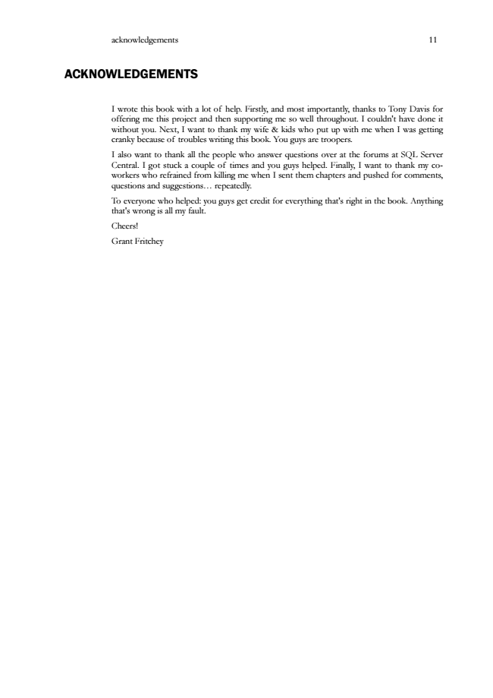

acknowledgements 11

ACKNOWLEDGEMENTS

I wrote this book with a lot of help. Firstly, and most importantly, thanks to Tony Davis for offering me this project and then supporting me so well throughout. I couldn't have done it without you. Next, I want to thank my wife & kids who put up with me when I was getting cranky because of troubles writing this book. You guys are troopers.

I also want to thank all the people who answer questions over at the forums at SQL Server Central. I got stuck a couple of times and you guys helped. Finally, I want to thank my co- workers who refrained from killing me when I sent them chapters and pushed for comments, questions and suggestions... repeatedly.

To everyone who helped: you guys get credit for everything that's right in the book. Anything that's wrong is all my fault.

Cheers!

Grant Fritchey